# Student Survey (middle and high)

### SCHOOL NAME

Strongly Agree

Agree Neutral Disagree

Strongly Disagree

Not Applicable

**Purpose:** The purpose of this survey is to find out your opinions about your school.

**Instructions:** Read each statement about your school. Decide to what extent you agree or disagree and blacken the corresponding circle.

This is not a test. Please answer each question honestly. Your answers will be completely confidential.

**Purpose and Direction**

**Information About Me**

**Gender:**

Male Female

**Race:**

American Indian or Alaska Native

Asian

Black or African American Native Hawaiian

or Other Pacific Islander White

Two or more races

**Ethnicity:**

Hispanic or Latino

Not Hispanic or Latino

**Current Grade in School:**

5th 8th 11th

6th

9th

12th

7th

10th 13+

#### In my school…

* 1. program and services are available to help me succeed.
  2. the purpose and expectations are clearly explained to me and my family.
  3. a high quality education is offered.
  4. all students are treated with respect.
  5. teachers work together to improve student learning.

## Governance and Leadership

#### In my school…

* 1. rules are applied equally to all students.
  2. students treat adults with respect.
  3. the principal and teachers have high expectations for me.

## Teaching and Assessing for Learning

#### My school…

* 1. gives me multiple assessments to check my understanding of what was taught.
  2. provides me challenging curriculum and learning experiences.
  3. prepares me to deal with issues I may face in the future.
  4. motivates me to learn new things.
  5. offers opportunities for my family to become involved in school activities and my learning.
  6. makes sure there is at least one adult who knows me well and shows interest in my education and future.
  7. provides learning services for me according to my needs.

#### All of my teachers…

* 1. use a variety of teaching methods and learning activities to help me develop the skills I will need to succeed.
  2. change their teaching to meet my learning needs.
  3. explain their expectations for learning and behavior so I can be successful.
  4. use tests, projects, presentations and portfolios to check my understanding of what was taught.
  5. provide me with information about my learning and grades.
  6. keep my family informed of my academic progress.
  7. fairly grade and evaluate my work.

July 2022

**Continued >>**

# Student Survey (middle and high)

Agree Neutral Disagree

Strongly Disagree

### SCHOOL NAME

Strongly Agree

Not Applicable

**Resources and Support Systems**

#### In my school…

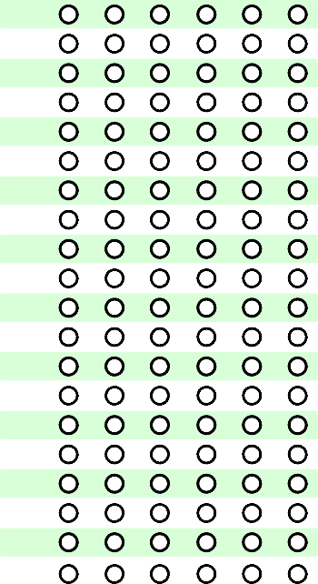

**Additional School-specific Items**

If you have been provided with additional items, please respond in this area.

**A B C D E F**

1.

2

3.

4.

5.

6.

7.

8.

9.

10.

11.

12.

13.

14.

15.

16.

17.

18

19.

20.

* 1. the building and grounds are safe, clean, and provide a healthy place for learning.
  2. students respect the property of others.
  3. a variety of resources are available to help me succeed (e.g., teaching staff, technology, media center).
  4. computers are up-to-date and used by teachers to help me learn.
  5. students help each other even if they are not friends.
  6. I can participate in activities that interest me.
  7. I have access to counseling, career planning and other programs to help me in school.

**Using Results for Continuous Improvement**

#### My school…

* 1. shares information about school success with my family and community members.
  2. considers students' opinions when planning ways to improve the school.
  3. prepares me for success in the next school year.

**Open-ended Items** (Use a separate sheet if additional space is needed.)

1. What do you like best about your school?
2. What do you like least about your school?
3. What is one suggestion you would like to offer to improve your school?

July 2022

**Thank you for taking the time to complete and return this survey!**