# Parent Survey

### SCHOOL NAME

**Purpose and Direction**

**Information About Me**

**Gender:**

Male Female

**Race:**

American Indian or Alaska Native

Asian

Black or African American Native Hawaiian

or Other Pacific Islander White

Two or more races

**Ethnicity:**

Hispanic or Latino

Not Hispanic or Latino

**Oldest Child's Grade in this School:**

Pre-K

K 1

2

3

4

5

6

7

8

9

10

11

12

#### Our school's purpose statement is…

* 1. clearly focused on student success.
  2. formally reviewed and revised with involvement from parents.

#### Our school has…

* 1. established goals and a plan for improving student learning.

**Governance and Leadership**

#### Our school's governing body…

* 1. operates responsibly and functions effectively.
  2. does not interfere with the operation or leadership of our school.

#### Our school…

* 1. has high expectations for students in all classes.
  2. shares responsibility for student learning with its stakeholders.
  3. communicates effectively about the school goals and activities.
  4. provides opportunities for stakeholders to be involved in the school.

## Teaching and Assessing for Learning

#### All of my child's teachers…

* 1. provide an equitable curriculum that meets his/her learning needs.
  2. give work that challenges my child.
  3. use a variety of teaching strategies and learning activities.
  4. meet his/her learning needs by individualizing instruction. e work as a team to help my child learn.

1. help me to understand my child's progress.
2. keep me informed regularly of how my child is being graded.
3. report on my child's progress in easy to understand language.

#### My child…

* 1. sees a relationship between what is being taught and his/her everyday life.
  2. knows the expectations for learning in all classes.
  3. has at least one adult advocate in the school.
  4. is given multiple assessments to measure his/her understanding of what was taught.
  5. has up-to-date computers and other technology to learn.
  6. has access to support services based on his/her identified needs.

**Continued >>**

July 2022

**Purpose:** The purpose of this survey is to find out your opinions about your child's school.

**Instructions:** Read each statement about your school. Decide to what extent you agree or disagree and blacken the corresponding circle.

This is not a test. Please answer each question honestly. Your answers will be completely confidential.

Strongly Agree

Agree Neutral Disagree

Strongly Disagree

Not Applicable

# Parent Survey

Agree Neutral Disagree

Strongly Disagree

### SCHOOL NAME

Strongly Agree

Not Applicable

**Resources and Support Systems**

#### Our school provides…

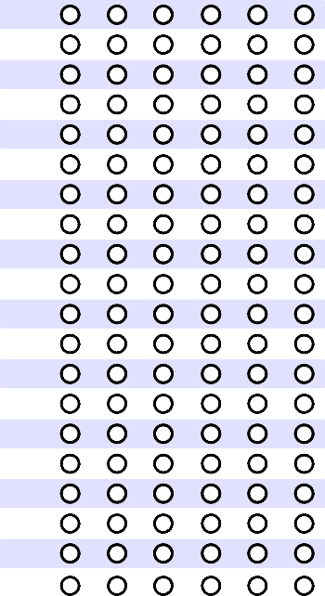

**Additional School-specific Items**

If you have been provided with additional items, please respond in this area.

**A B C D E F**

1.

2

3.

4.

5.

6.

7.

8.

9.

10.

11.

12.

13.

14.

15.

16.

17.

18

19.

20.

* 1. qualified staff members to support student learning.
  2. an adequate supply of learning resources that are current and in good condition.
  3. a safe learning environment.
  4. students with access to a variety of information resources to support their learning.
  5. excellent support services (e.g., counseling, career planning).
  6. opportunities for students to participate in activities that interest them.

#### Our school ensures…

* 1. the facilities support student learning.
  2. effective use of the financial resources.
  3. instructional time is protected and interruptions are minimized.

**Using Results for Continuous Improvement**

#### Our school ensures...

* 1. that all staff monitor and report the achievement of school goals.

#### My child…

* 1. is prepared for success in the next school year.
  2. has administrators and teachers that monitor and inform me on his/her learning progress.

**Open-ended Items** (Use a separate sheet if additional space is needed.)

1. What do you like best about your school?
2. What do you like least about your school?
3. What is one suggestion you would like to offer to improve your school?

July 2022

**Thank you for taking the time to complete and return this survey!**